Day 4-test

Reversing a number: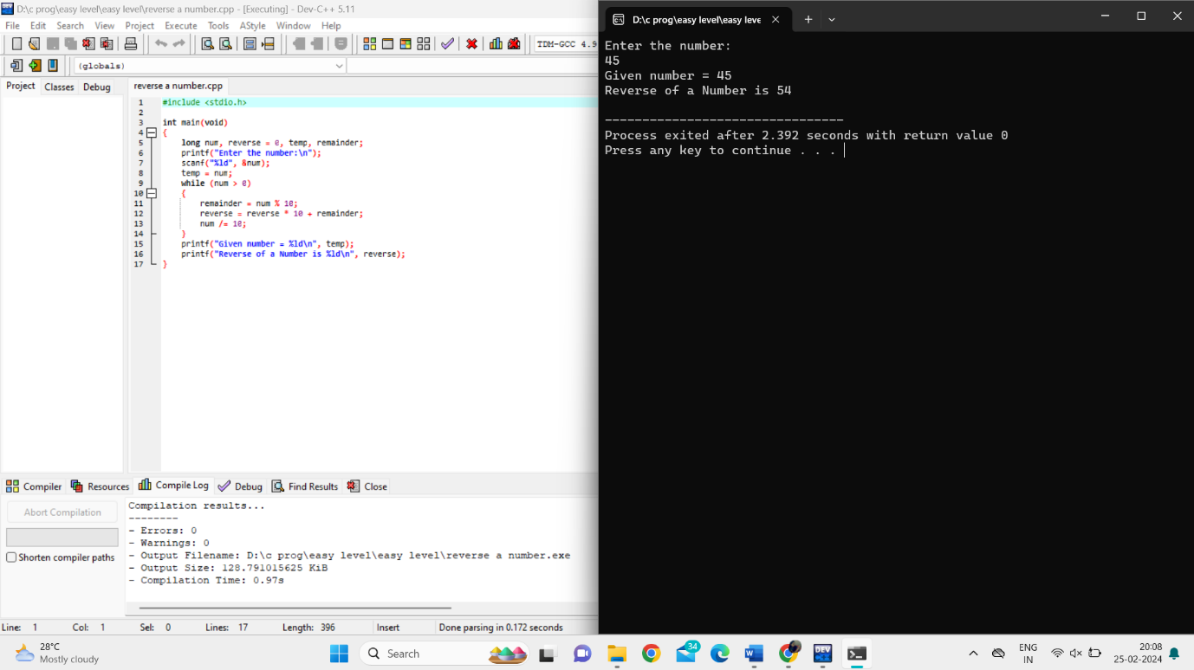

Reversing a number and check if the number is palindrome or not:

Prime number in a given range: 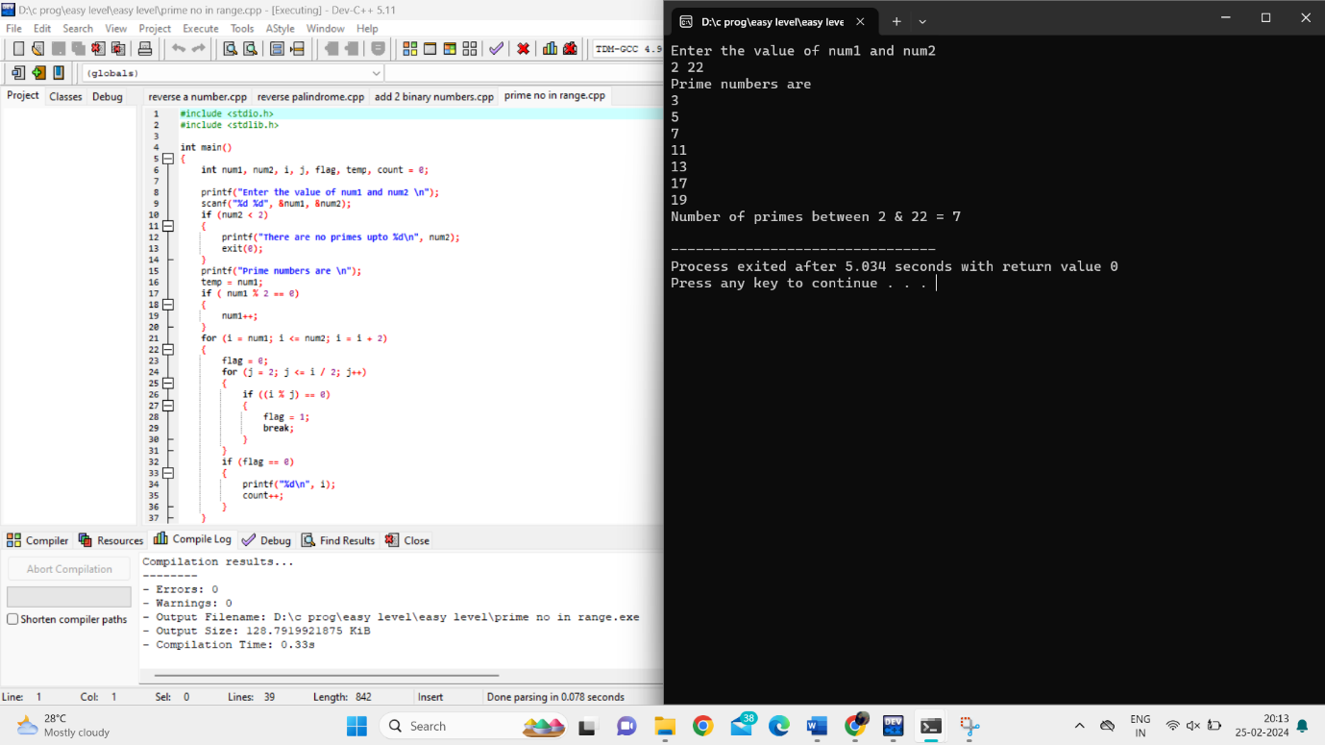

Leap year or not:

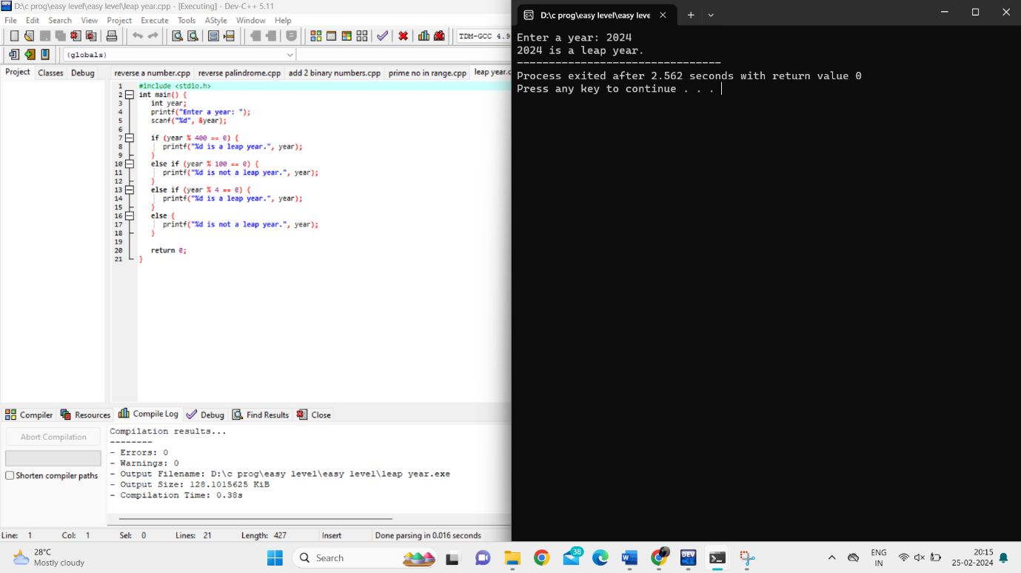

Add 2 binary numbers: